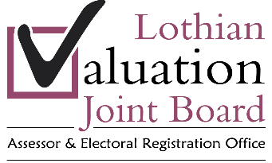

Person Specification

Job Title | Trainee Technician

ATTRIBUTES | ESSENTIAL  REQUIREMENTS | DESIRABLE  REQUIREMENTS | METHOD OF ASSESSMENT
PROFESSIONAL/  EDUCATION/  QUALIFICATIONS | - Minimum academic qualifications:  1 higher and 4 National 5s at C or above, which must include Mathematics and English. |  | Application
RELEVANT WORK/OTHER EXPERIENCE | - Experience of working with the public. | - General competence in the survey of all categories of domestic and non-domestic property.  - Knowledge of the local housing market.  - Any property related work experience. | Application/  Interview
PARTICULAR SKILLS/ABILITIES  (eg technical ability, computing skills, other work related skills) | - Ability to use IT systems.  - Good communication skills and experience of dealing with the public in writing and verbally. |  | Application/  Interview
PERSONAL QUALITIES  (eg inter-personal skills, attitude, adaptability, motivation, presentation) | - Display positive attitude.  - Flexible approach to duties. | - Ability to make decisions quickly and effectively, exercise initiative and recognition of when to pass work to Technician.  - Motivated to qualify as a Technician. | Application/  Interview
ANY ADDITIONAL  JOB RELATED REQUIREMENTS  (eg ability to work irregular hours, shifts) | - Must commit to enrol and work towards HNC in Built Environment or equivalent.  - Willingness to travel within Edinburgh and the Lothians. | - Full current driving licence. | Application/  Interview

