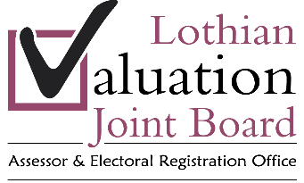
Job Description

Job Title: | Trainee Technician
Grade: | GS1 – AP1

PURPOSE OF JOB

- To assist qualified staff in maintaining Valuation Roll and Council Tax List.

- To carry out survey, measurement for Council Tax purposes.

- To undertake the survey, measurement of non domestic properties as required.

JOB ACTIVITIES

- Assist in the valuation of all categories of dwelling for Council Tax purposes.

- Maintaining computer and hard copy files relating to Council Tax.

- Assisting in the development and implementation of IT programmes for Council Tax purposes.

- Assist in the analysis of sales evidence to establish Council bands and values.

- Preparation of evidence for use before local Valuation Appeal Committee.

- Survey of all categories of non-domestic property.

- Maintaining computer and hard copy records for non domestic property.

LINE MANAGEMENT RESPONSBILITY

- None.

DECISIONS MADE

- Liaising with colleagues in other geographical teams to ensure consistency of practice.

SUPERVISION RECEIVED

- Reports to Divisional Valuer.

- Day to day supervision from Technicians and Valuation Services Team Manager.

- Expected to work with decreasing supervision as training progresses.

CONTACTS

- The general public.

- All staff.

- Departmental staff of the four constituent councils.

- House builders.

QUALIFICATIONS

- Minimum qualifications required to sit HNC in Built Environment or equivalent.

EXPERIENCE

- Competent to commence training in the survey of all categories of domestic and non domestic property.

- Competent to commence training to analyse sales evidence and apply banding levels.

COMPLEXITY

- Knowledge of local housing market.

- Maintenance of hard copy and Information Technology based record systems.

- Compliance with best value requirements.

- Correspondence with taxpayers.

- Maintenance of effective contacts with the four constituent councils.

CREATIVITY

- Prioritisation of Council Tax work.

- Preparation of reports.

- Provision of recommendations to technical staff.

- Correspondence with taxpayers.

- Preparation of material before Valuation Appeal Committee.

- Acting in accordance with principles of Best Value.

SPECIAL CONDITIONS

- It will be a requirement of the post that the post-holder obtains a Basic Disclosure from Disclosure Scotland.

- Willingness to travel. Full current driving licence is desirable.

- Any other duties pertinent to post.

